Step-by-Step: a Simple Continuous Psychophysics Experiment Designed in PsychoPy

The following is a step-by-step guide to create a approachably simplified version of the seminal tracking experiment reported by Bonnen et al. (2015) in PsychoPy.

- Create object to be tracked
Choose “Polygon” from the right-hand column under “Stimulus”.
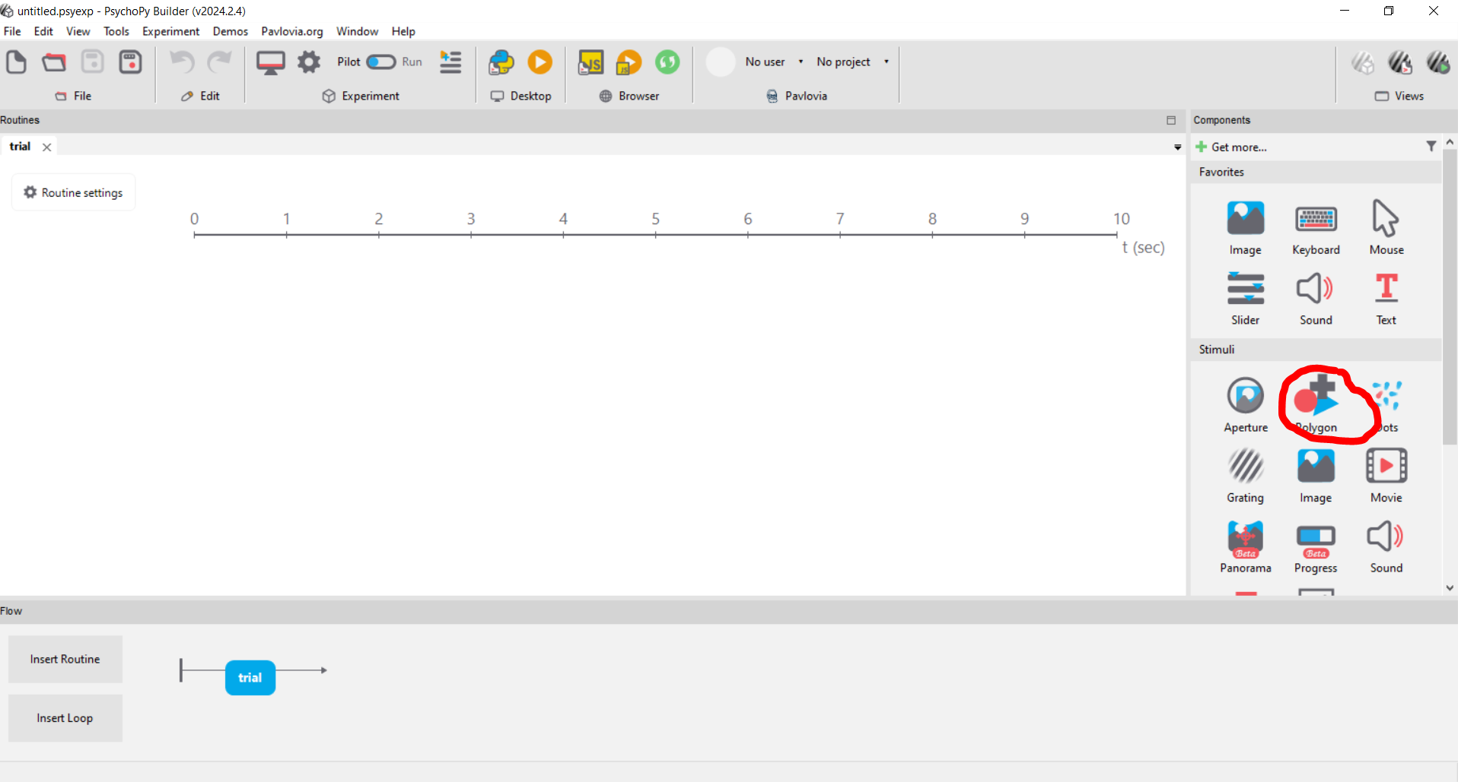
  - Under “Basic”:
    - Leave “Duration” empty
  - Under “Layout”:
    - Set Spatial Units to “cm”
  - Under “Appearance”:
    - Write “opacity” in the Opacity field

- Create a representation of mouse cursor
Chose “Mouse” under “Responses”.
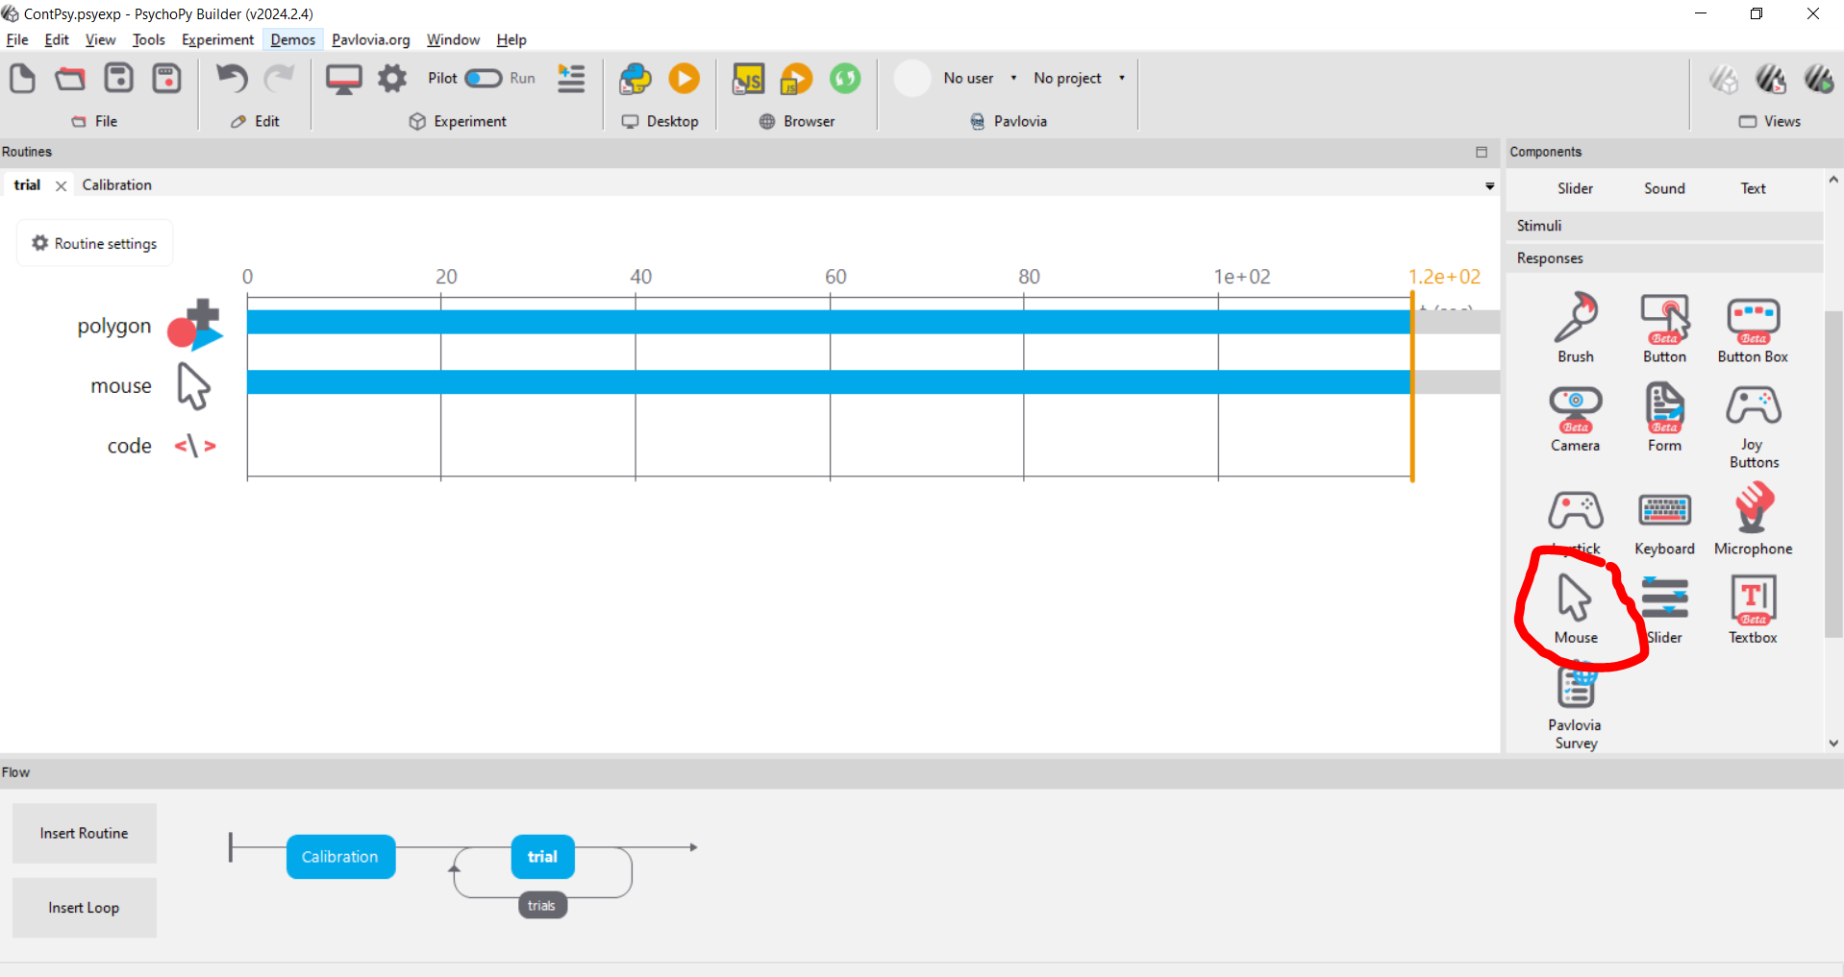
  - Under “Basic”:
    - Leave “Duration” empty
    - For “End Routine on Press”, choose “never”

- Create the code object
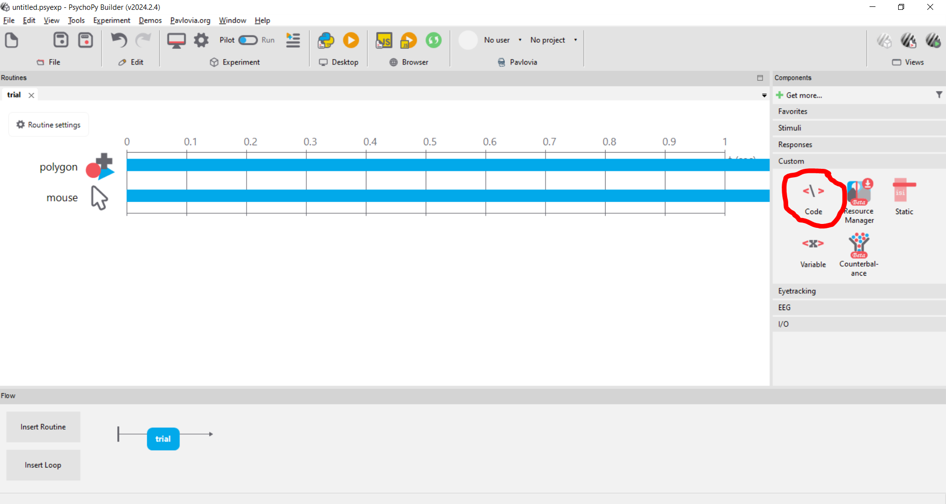
  - We are returning to this later!

- Configure Routine
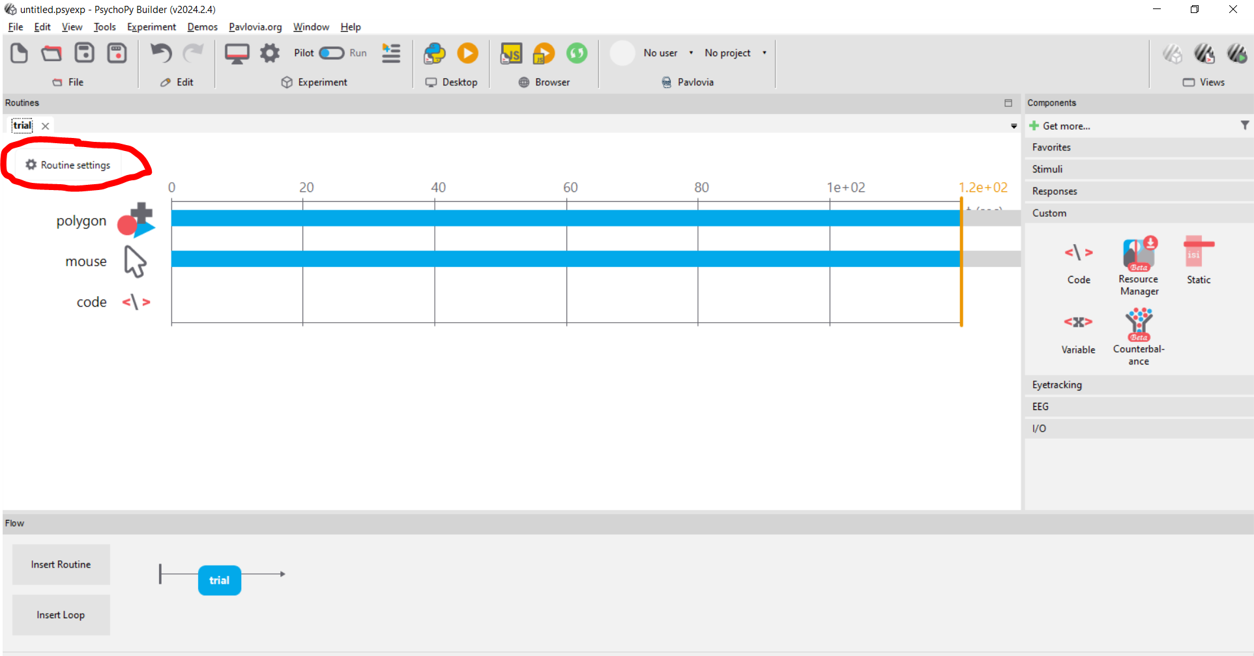
  - Under “Flow”:
    - Set Duration to 120s

- Create a loop
(This allows us to run the same routine twice – once with high opacity and once with low opacity. The opacity will be set using the “custom code” feature – see below.)
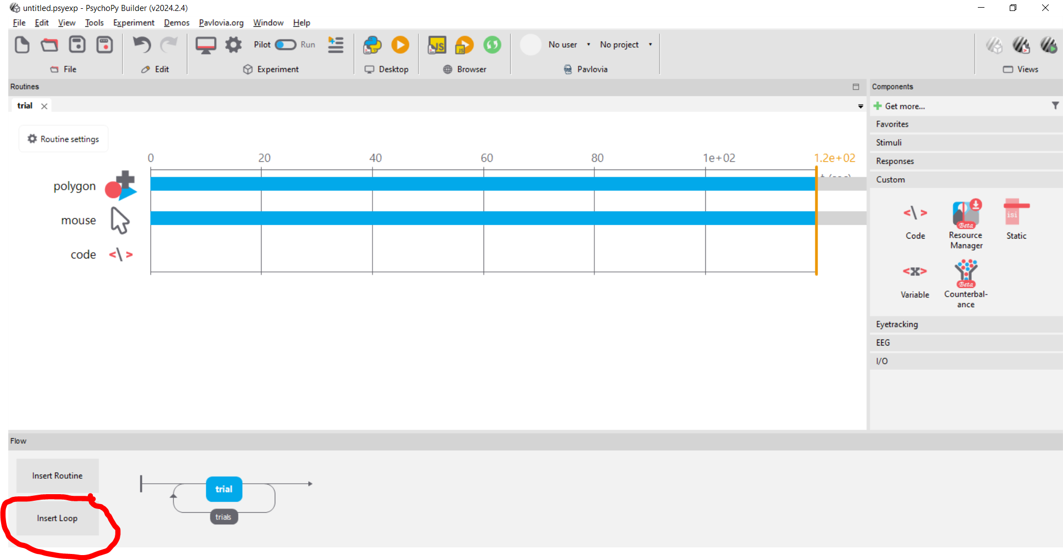
  - Click on “Insert Loop” and then click on one of the two dots that appears to the left and right of the “trial” box in the bottom ribbon.
    - Set “Num. Repeats” to 2

- Add calibration routine in the beginning of the experiment
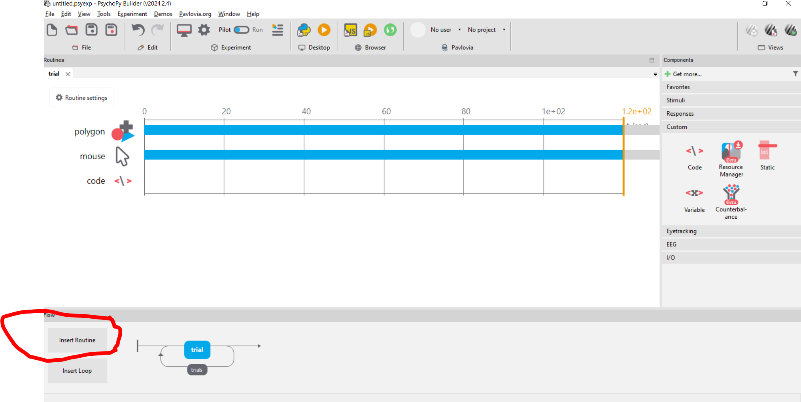
  - Insert a new Routine before “trial”. Name it “Calibration” and click on the circle to the left of “trial” to insert it.
  - Add a Polygon
    - Under “Basic”:
      - Leave “Duration” empty
    - Under “Layout”:
      - Set “Size” to (0.05, 0.05)
      - Set “Position” to (0.5, 0.5)
      - Set “Spatial Units” to “cm”
  - Add representation of mouse cursor
    - Under “Basic”:
      - Leave “Duration” empty
      - Set “End Routine on press” to “any click”
      - Set “Clickable Stimulus” to “Polygon_2” (the polygon we created for this routine)

- Fill in code
We use custom code for features that PsychoPy’s graphical interface does not currently support (random walk in stimulus position, saving data frame-by-frame).
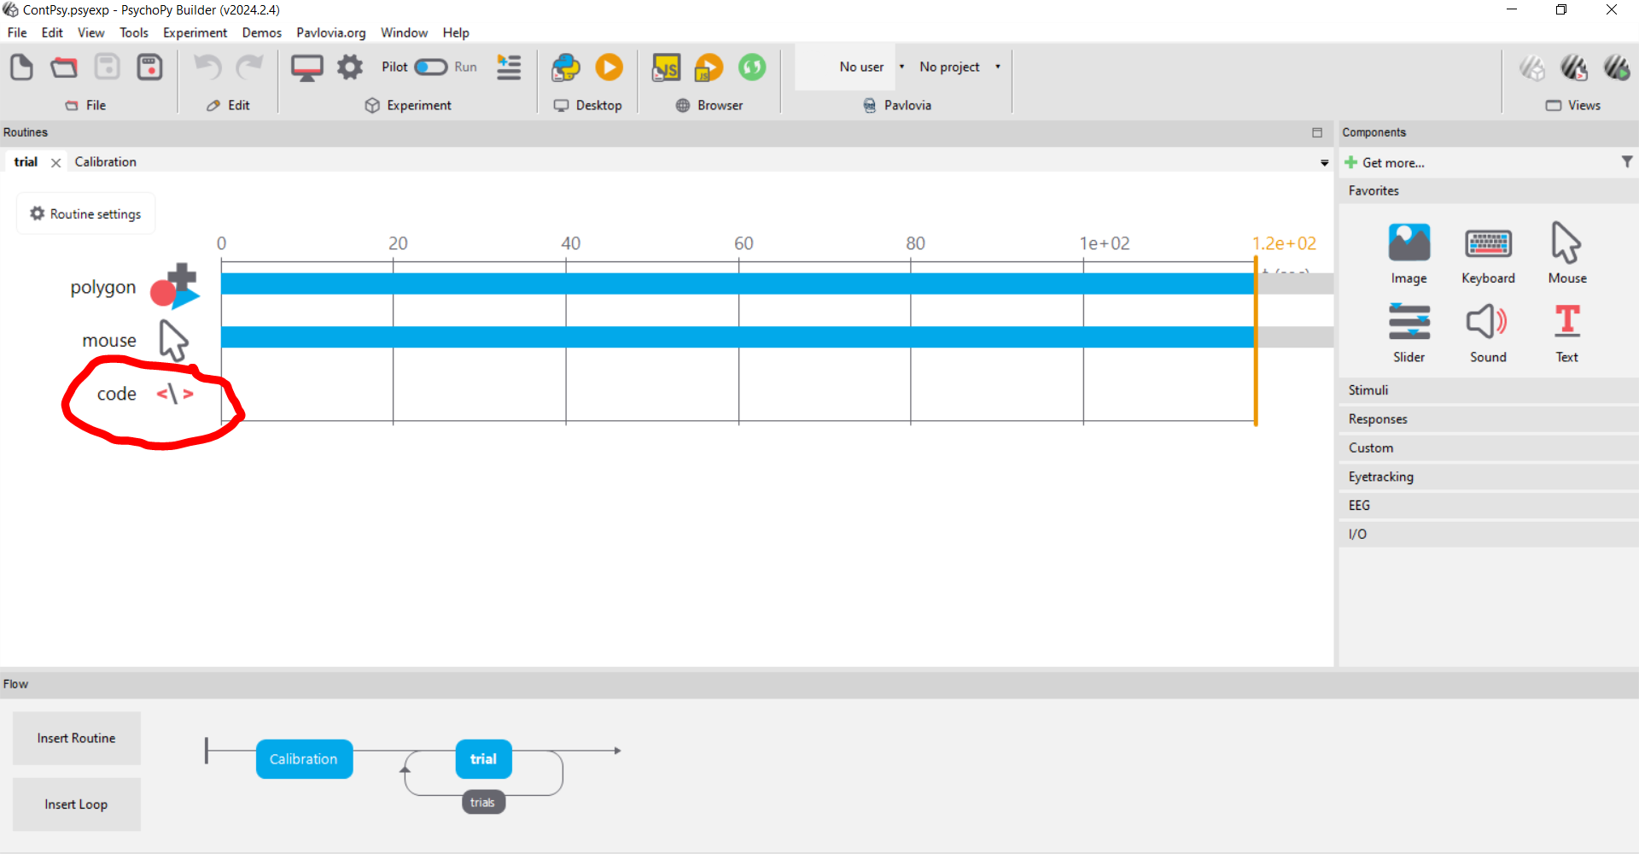
  - Under “Before experiment”, add:
#Load required packages: numpy for the random walk, time to keep track of the temporal #aspect of the experiment
import numpy
import time

  - Under “Begin Experiment”, add:
#Here we randomize which opacity we start with.
a = [0.03,1]
opacity = numpy.random.choice(a)

  - Under “Begin Routine”, add:
#We reset the initial position of the dot at the beginning of each run/routine.
posx = 0
posy = 0
pos = (posx, posy)

#Save the time in the beginning of each run so we know how long it's been running
start = time.time()

  - Under “Each Frame”, add:
#start moving the dot only after 3 seconds
if time.time() - start > 3:

#draw the next step for the random walk for x and y directions
Addx = numpy.random.normal(loc=0,scale = 0.3)
Addy = numpy.random.normal(loc=0,scale = 0.3)

#add the next step to the current position,
#but make sure we don't go off screen (set at +- 6cm from middle of screen)
if posx + Addx < 6 and posx + Addx > -6:
posx = posx + Addx

if posy + Addy < 6 and posy + Addy > -6:
posy = posy + Addy

pos = (posx, posy)

#save the relevant data on each frame
thisExp.addData("time_in_run", time.time() - start)
thisExp.addData("x_coord_mouse", mouse.getPos()[0])
thisExp.addData("y_coord_mouse", mouse.getPos()[1])
thisExp.addData("x_coord_target", posx)
thisExp.addData("y_coord_target", posy)
thisExp.addData("opacity", opacity)
thisExp.nextEntry()

  - Under “End Routine”, add:
#change opacity from the one we ran first to the other one
if opacity == 0.03:
opacity = 1
else:
opacity = 0.03

